- Introduction

- Number of accident Vs Suburb(City), plot to heat map – Jing

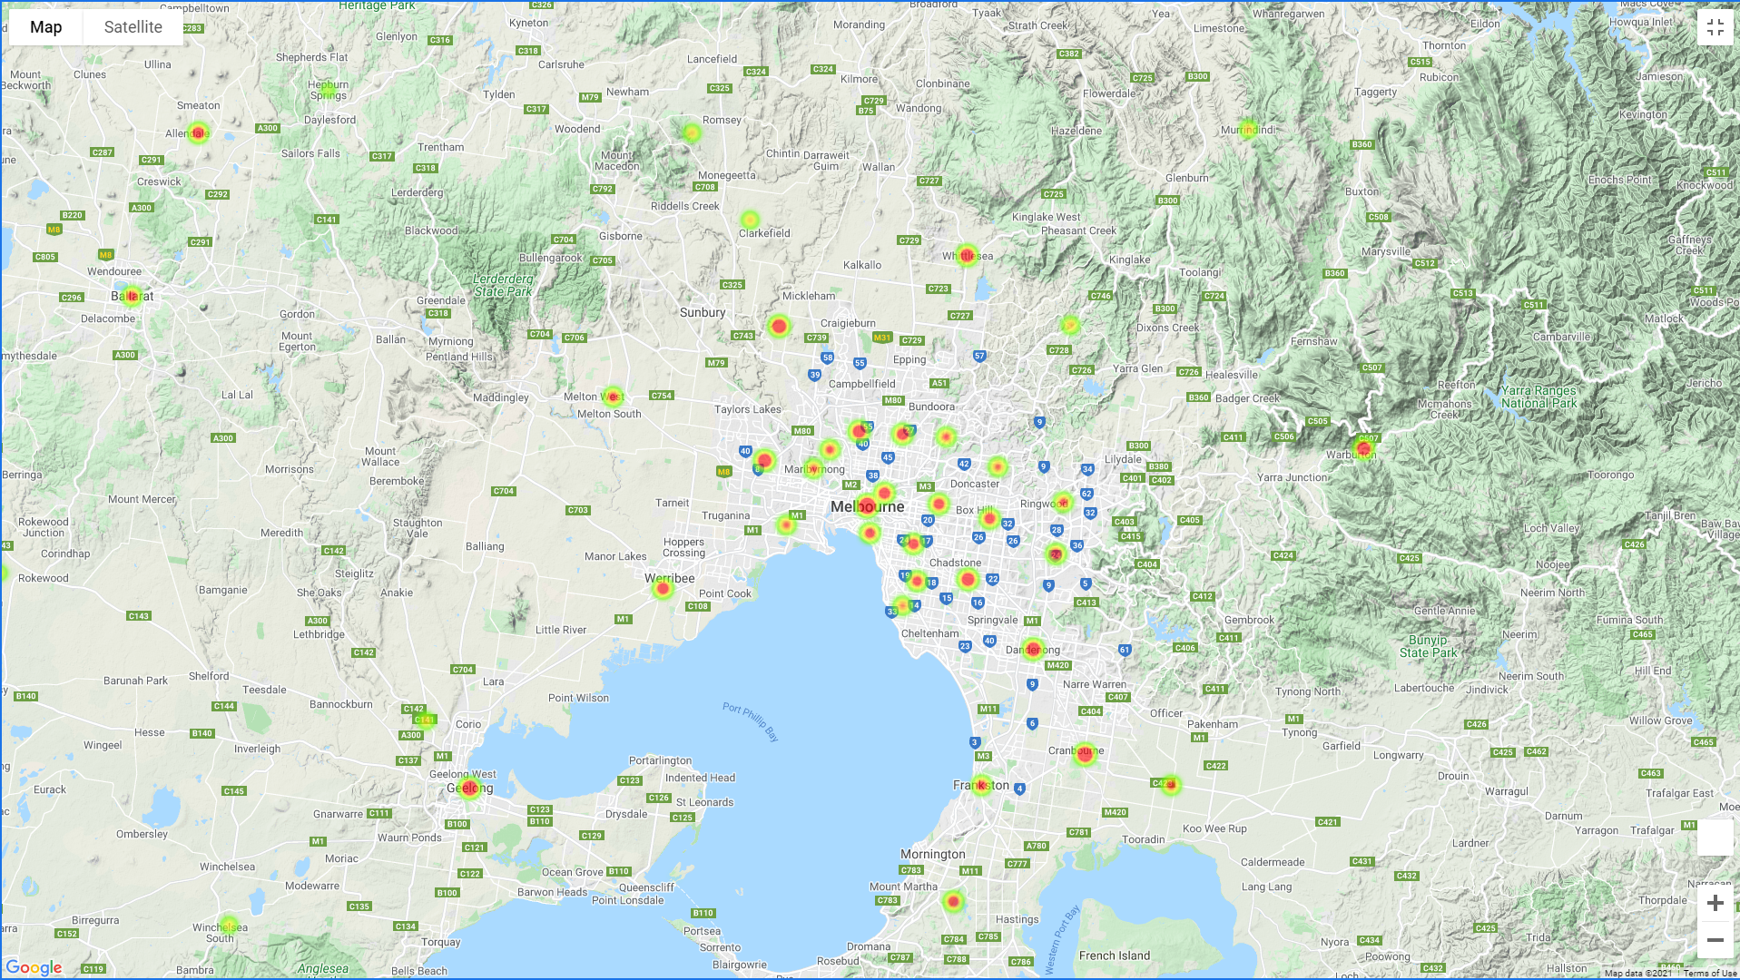

- Top 10 City with higest number of accidents over the 5 years - Jing

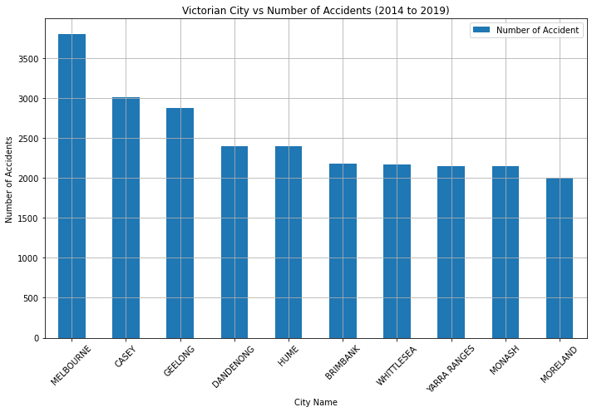

-Nearst Medical Centre in the top 10 hot spots – Jing

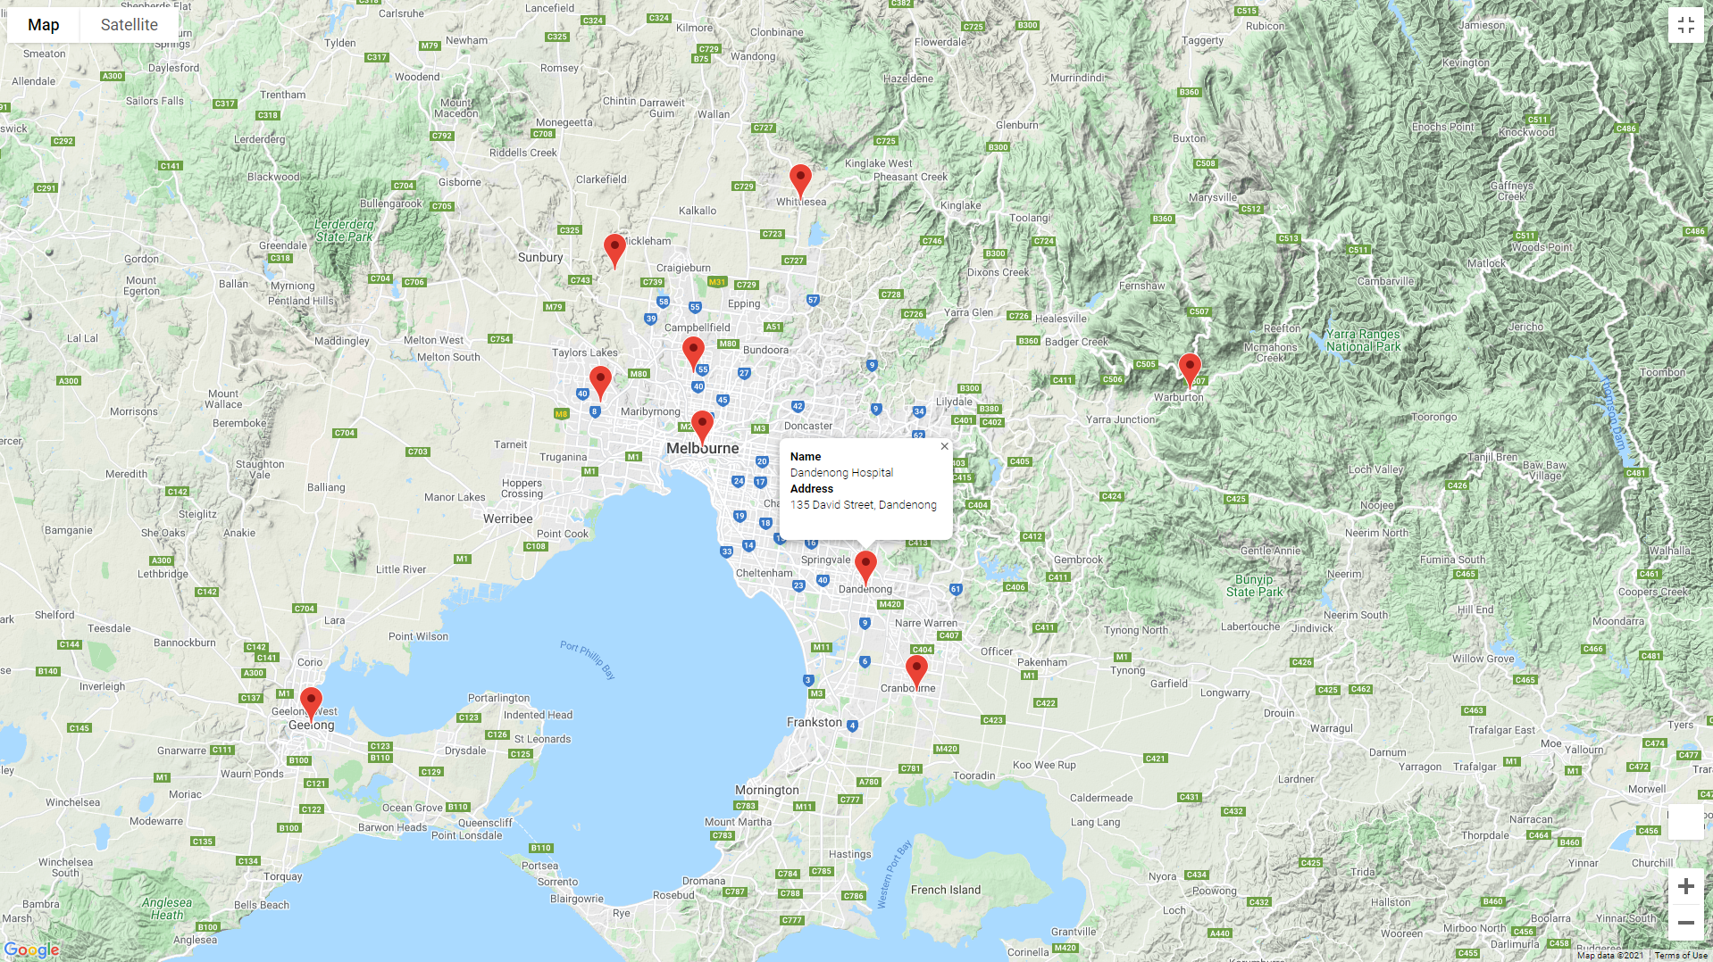

-Accident rate over the 4 full years (2015-2018) – Ajay

-Extend your analysis to why it’s decreasing, and propose future analyst:

* Increased fine/panalty?
* Better car techology? (auto pilot, auto parking etc, better GPS system etc)
* Decreased rainfall?
* More cars registered?
* stricter road safety laws
* measures put in place by transit authorities and safer vehicle standards

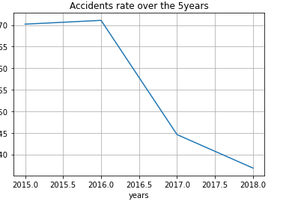

-Type of accident over the years - Ajay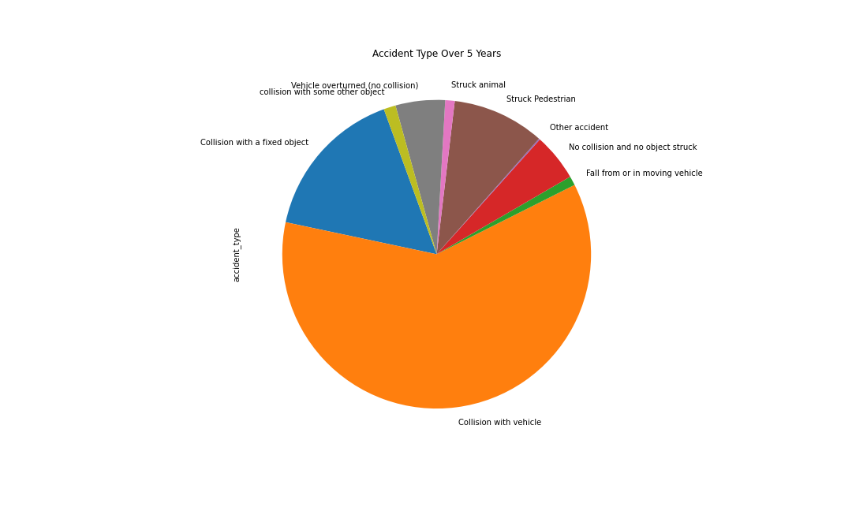

-Light Condition vs Number of Accidents – Ajay

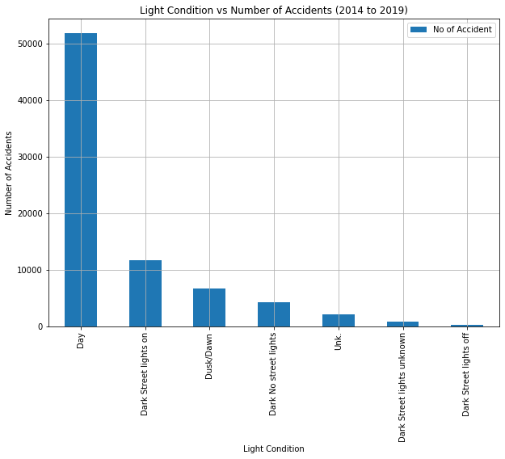

**Total Number of Accidents based on the region**

